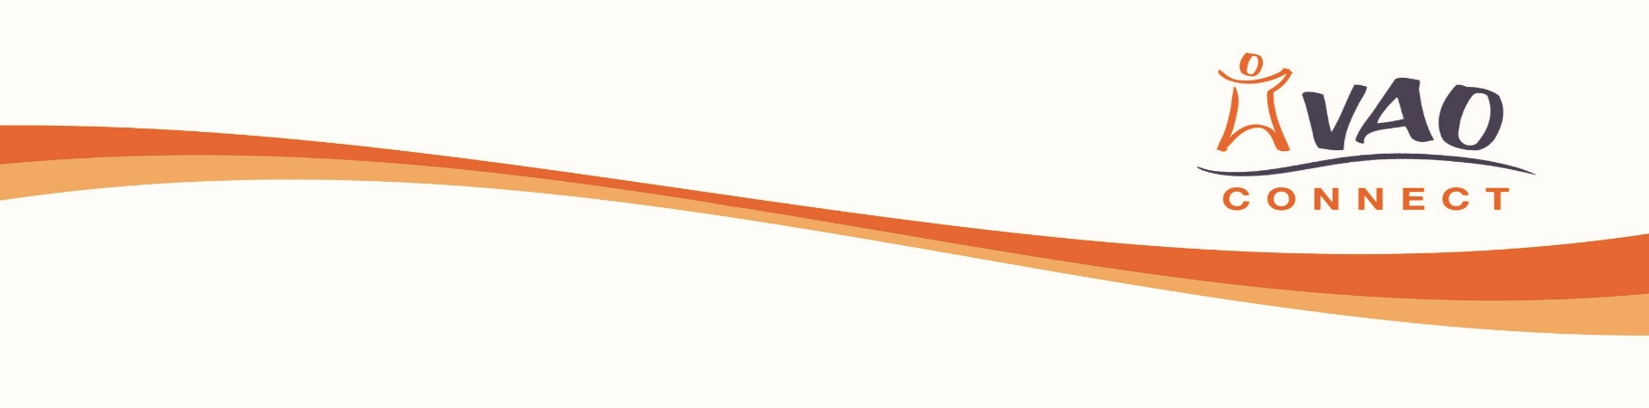

Connect Project

|  |  |  |  |  |  |  |  |  |
| --- | --- | --- | --- | --- | --- | --- | --- | --- |
| **Referred by**: | | | | Name of contact:  Contact Phone Number:  Contact email: | | | | |
| Address: | | | |
| **Young Persons Details:** | | | | | | | | |
| Name:  Address: | | | | | D.o.B: | | | |
| Contact Number: | | | |
| Sex: | | | |
| **Reason for Referral** | | | | | | | | |
| Please give as much detail of what we should know about the young person e.g. routines, interests, second language, social skills, health issues, attendance, risk taking behaviour, chaotic lifestyle, confidence, etc. as well as aspects that are going well for the young person: | | | | | | | | |
| **Please tick all agencies that the young person is involved with** | | | Contact name | | | | Email/tel. | |
| School | |  |  | | | |  | |
| Social work | |  |  | | | |  | |
| Educational psychologist | |  |  | | | |  | |
| Skills Development Scotland | |  |  | | | |  | |
| Health professionals | |  |  | | | |  | |
| UHI Orkney | |  |  | | | |  | |
| Other (please specify) | |  |  | | | |  | |
| Work already undertaken by referrer: | | | | | | | | |
| Signature of young person  (confirming that they give consent for this referral) |  | | | | | Date | |  |
| Signature of Referrer |  | | | | | Date | |  |

**Please return this form** to: Karen Mack, Connect Co-ordinator, Voluntary Action Orkney,   
Anchor Buildings, 6 Bridge Street, Kirkwall, Orkney KW15 1HR

Email [karen.mack@vaorkney.org.uk](mailto:karen.mack@vaorkney.org.uk)

**Data Protection Act**

The information you have provided will help us to provide an individual programme for the young person you have referred, and allow us to monitor the quality of our service. No personal details will be given to anyone without your express permission unless it is necessary to do so to comply with the law or with police investigations. Information about gender, age, or referral reason may be disclosed to, for example, our funders or in our annual report but will be in statistical form only and not in any way that identifies the young person. The information will be held on our database and used in accordance with the General Data Protection Regulations 2018



karen.mack@vaorkney.org.uk

01856 872897

Enquiries @vaorkney.org.uk

Anchor Buildings, 6 Bridge St, Kirkwall, Orkney KW15 1HR

www.orkneycommunities.co.uk/VAO

*Voluntary Action Orkney (VAO) is a charitable company limited by guarantee. Registered in Scotland No 143208.*

*Registered Office: Anchor Buildings, 6 Bridge Street, Kirkwall, KW15 1HR. Registered Scottish Charity No SCO10691*