Child or Young Person’s Details:
First Name: |  | Social Worker (if appropriate):
Surname: |  | Social Worker (if appropriate):
Date of Birth: | Age: | Legal Status:  - On child protection register  - Looked after : not accommodated  - Looked after & accommodated : foster care  - Looked after & accommodated : residential  - Looked after & accommodated : relative/friend  - No statutory order in place
Gender:
Address:

Postcode:
Name of main carer(s) and relationship to child:

Address if different to above:  Postcode: |  | Additional Support Needs:
Main carer email:
Home number:

Mobile number:

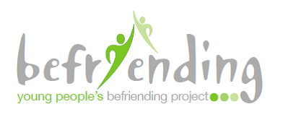
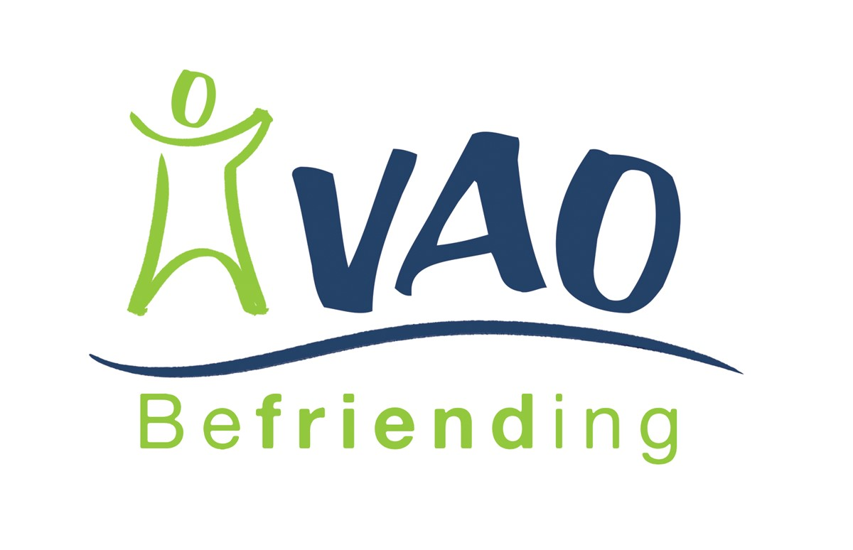
Referral form

Please complete this form and return it to:
Young People’s Befriending Project
Voluntary Action Orkney
6 Bridge Street,
Kirkwall Email : hannah.rendall@vaorkney.org.uk
KW15 1HR Call : 01856 872897

PLEASE NOTE – If you are a parent/guardian/carer looking for a Befriender for your own child, please nominate a professional working in your child’s life to be their referrer by passing this form onto them. This could be a teacher, social worker, health professional, counsellor, support worker etc.
Thank you.

Young People’s Befriending Project
Voluntary Action Orkney

Family details and household members:
Name | Age: | Date of Birth | Gender: | Relationship: | Address:

Key Contacts (e.g. school, GP, other professionals with whom the family have contact):
Name: | Role? | Place of work: | Contact Number: | Length of involvement:
Young People’s Befriending Project
Voluntary Action Orkney

Brief outline of the young person’s circumstances:
Specific reason/s for referral:
Are there any alcohol/substance misuse issues in the family?
Young People’s Befriending Project
Voluntary Action Orkney

How might the young person’s additional support needs impact on their befriending experience?
How does the young person relate to adults/other young people?
Please comment on the attitude of the family/young person towards volunteer involvement:
Young People’s Befriending Project
Voluntary Action Orkney

Is there any additional information we should know about the young person (known to run away, alcohol/substance use, prone to show violence, any travelling difficulties etc)?
Young person’s hobbies and interests:
What do you think the young person might gain from a Befriender?
Young People’s Befriending Project
Voluntary Action Orkney

Please give a description of the type of Befriender you think would suit the young person, i.e gender, age, interest etc :

Young People’s Befriending Project
Voluntary Action Orkney

Referrers details:
Name:
Position:
Organisation/department:
Address:

Postcode:
Contact No:
Email:

Data Protection Act

The information you have provided will help us to find a suitable Befriender for the young person you have referred and allow us to monitor the quality of our service. No personal details will be given to anyone without your express permission unless it is necessary to do so to comply with the law or with police investigations. Information about gender, age, or referral reason may be disclosed to, for example, our funders or in our annual report but will be in statistical form only and not in any way that identifies the young person. The information will be held on our database and used in accordance with the Data Protection Act 1998.

Please ensure you have the consent of both the young person and their parent/carer before you sign and return this form :
Signed:
Date:

Voluntary Action Orkney (VAO) is a charitable company limited by guarantee.
Registered in Scotland No. 143208. Registered Scottish charity No CO 10691

